**LAB 2 – Part 1**

Create this simple synthesizer below using the file “Lab2 - Part 1-DEMO.maxpat”

To complete the patch, follow the instructions on the side of the starting patch provided and/or follow the walkthrough video here:

**https://media.ucsc.edu/V/Video?v=4108399&node=14016513&a=167708289&autoplay=1**

**Due: turn in a screen shot of your finished patch and name it as follows: “lastname firstname lab 2 part 1”**

Follow the class demonstration and the extensive comments within the patch to guide you to make this patch pictured below.

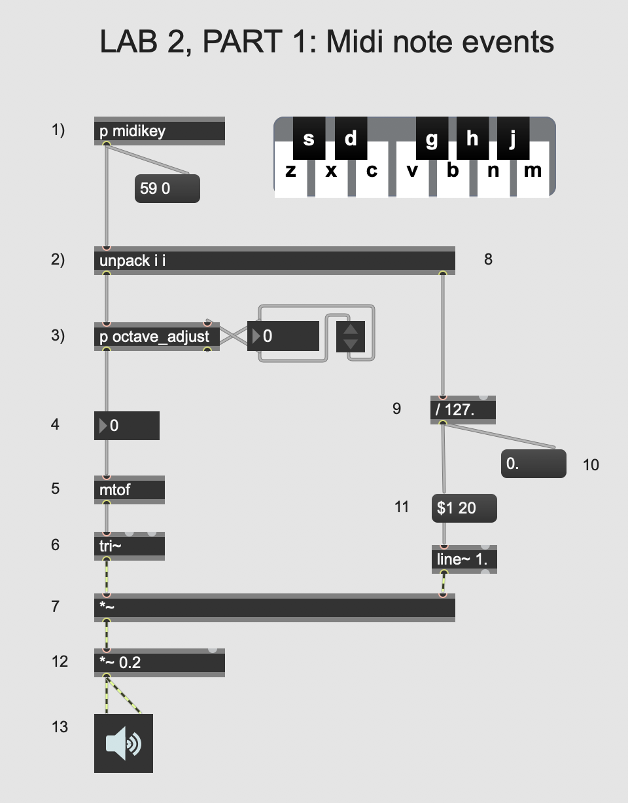

**LAB 2 – Part 2**

Create this simple synthesizer below using the file “Lab2-Part 2-DEMO.maxpat”

To complete the patch, follow the instructions on the side of the starting patch provided and/or follow the walkthrough video here:

**https://media.ucsc.edu/V/Video?v=4108402&node=14016516&a=203841660&autoplay=1**

**Due: turn in a screen shot of your finished patch and name it as follows: “lastname firstname lab 2 part 2”**

Follow the class demonstration and the extensive comments within the patch to guide your to make this patch pictured below.

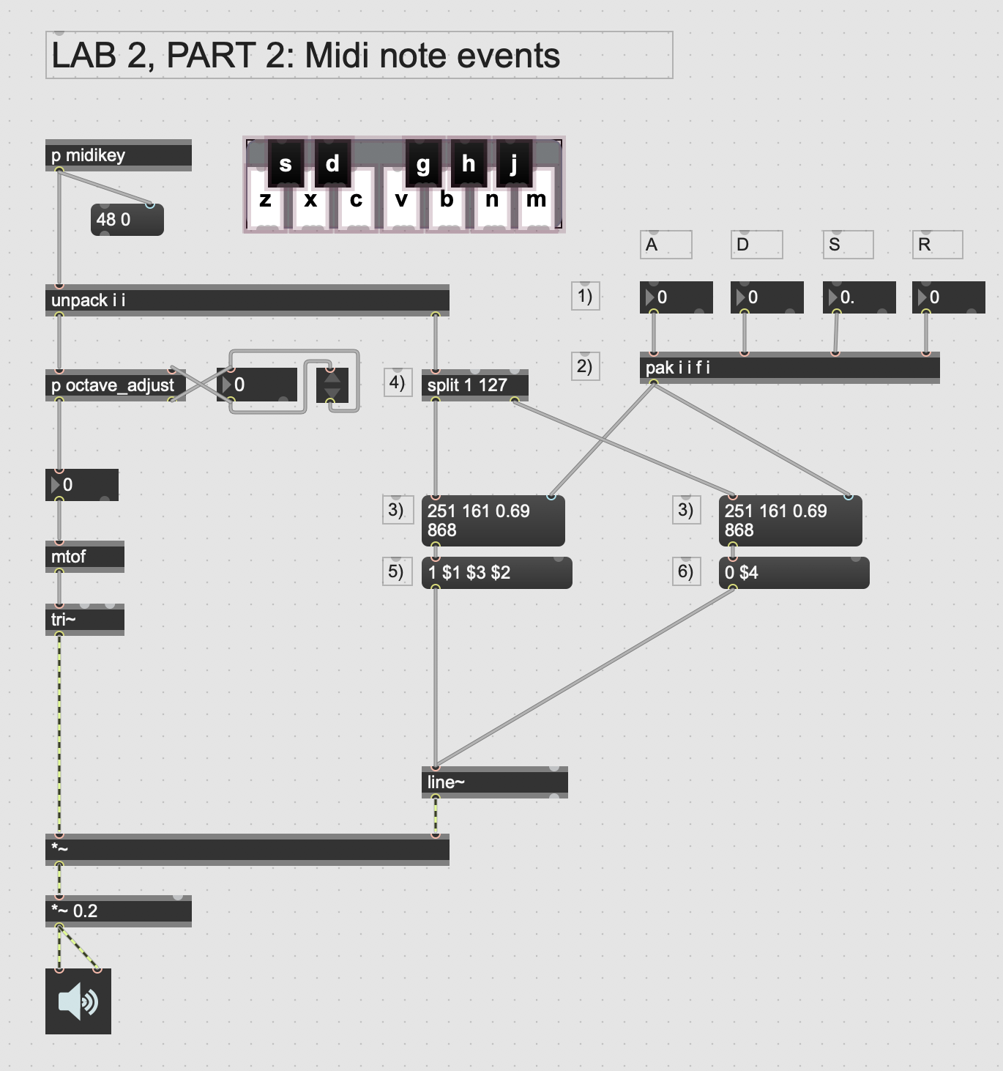

**LAB 2 – Part 3a**

Create this simple synthesizer below using the file “Lab2-Part 3a-DEMO.maxpat”

To complete the patch, follow the instructions on the side of the starting patch provided and/or follow the walkthrough video here:

**https://media.ucsc.edu/V/Video?v=4108403&node=14016517&a=38550283&autoplay=1**

**Due: turn in a screen shot of your finished patch and name it as follows: “lastname firstname lab 2 part 3a”**

Follow the class demonstration and the extensive comments within the patch to guide you to make this patch pictured below and also the encapsulated version of the ADSR. (See next page.)

­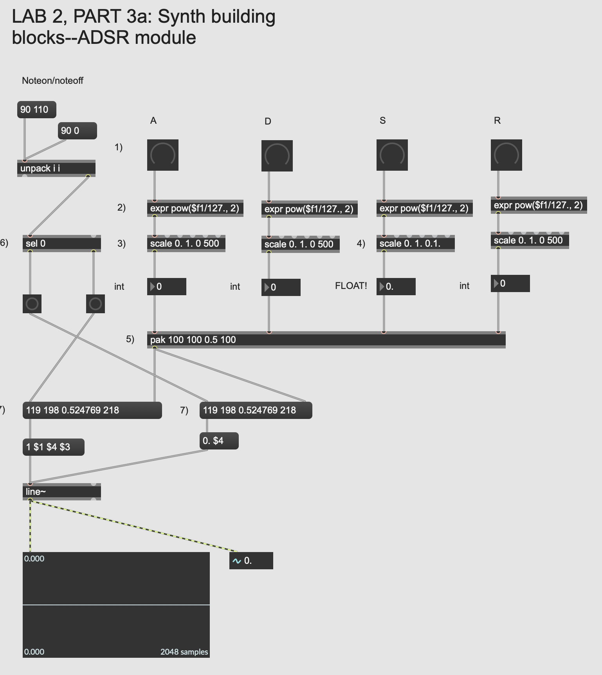

**LAB 2 – Part 3b**

Create this simple synthesizer below using the file “Lab2-Part 3b-DEMO.maxpat”

To complete the patch, follow the instructions on the side of the starting patch provided and/or follow the walkthrough video here:

**https://media.ucsc.edu/V/Video?v=4108907&node=14019233&a=141380422&autoplay=1**

**Due: turn in a screen shot of your finished patch and name it as follows: “lastname firstname lab 2 part 3b”**

Follow the class demonstration and the extensive comments within the patch to guide you to make this patch pictured below and also the encapsulated version of the LFO.

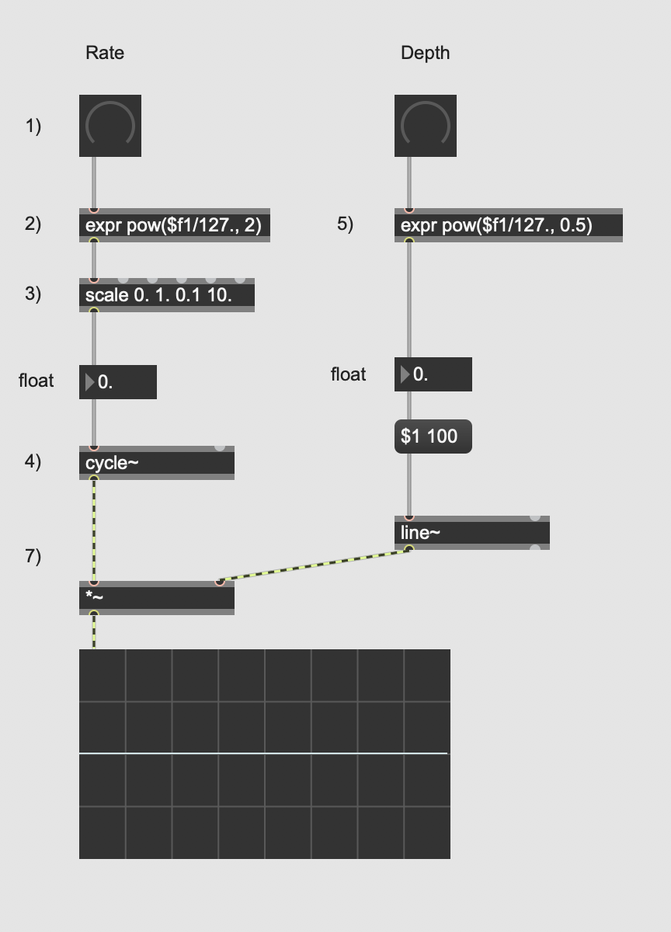

**LAB 2 – Part 4**

Create this simple synthesizer below using the file “Lab2-Part 4-DEMO.maxpat”

To complete the patch, follow the instructions on the side of the starting patch provided and/or follow the walkthrough video here:

**https://media.ucsc.edu/V/Video?v=4108908&node=14019234&a=143650316&autoplay=1**

**Due: turn in a screen shot of your finished patch and name it as follows: “lastname firstname lab 2 part 4”**

Follow the class demonstration and the comments within the patch to guide you to make this patch pictured. (See next page.)

